

**YEAR: 9**

**2018**

**SUBJECT: Science**

**TEST: Endocrine system & Diseases**

**TIME: 40 minutes**

**QUESTIONS: 10 Multiple Choice (10 marks)**

**6 Short Answer (26 marks)**

**1 Extended Response ( 5 marks)**

**TOTAL MARKS: 41 marks**

**DO NOT WRITE ON OR MARK THIS PAPER**

Section 1 – Multi-choice **(10 marks)**

1. Name the hormone that helps control water levels in the blood.
2. thyroid stimulating hormone
3. insulin
4. antidiuretic hormone
5. epinephrine
6. From the list below, select the pair of organs or glands that are included in the endocrine system
   1. Heart and hypothalamus
   2. Blood and pituitary gland
   3. Heart and adrenal gland
   4. Blood and appendix
7. The role of the antibody is
   1. To ingest pathogens
   2. Release a chemical that causes increased blood flow to the infected area
   3. To cause the pathogens to clump together so macrophages can destroy more at one time
   4. To activate the third line of defence
8. If white blood cell activity is visible what line of defence has been breached?
   1. 1st line
   2. 2nd line
   3. 3rd line
   4. All of the above
9. Penicillin is
   1. A pathogenic bacteria
   2. The first successful antiviral
   3. An infectious disease
   4. The first successful antibiotic
10. To prevent the spread of disease, an infected person
    1. May be placed in quarantine
    2. Told to contact lots of people so they can build immunity
    3. Will be automatically given antibiotics
    4. Will be told to continue on with their normal lives
11. Which disease has a vaccine available for it?
    1. Influenza
    2. HIV
    3. Leprosy
    4. Ebola
12. Which of the following will stimulate the production of an antibody?

a. Hormones.  
 b. Antibiotics  
 c. Enzymes  
 d. Antigens.

1. After using the toilet you should wash your hands with soap and water in order to

a. suffocate the microorganisms.  
 b. kill all the bacteria on your hands.  
 c. remove bacteria from your skin.  
 d. hydrate the bacteria.

1. The essential difference between a virus and bacteria is that a virus

a. can only be spread by personal contact.  
 b. reproduces by sexual methods.  
 c. reproduces only in a living organism.  
 d. is a single celled organism.



**SEMESTER ONE 2018**

**Endocrine system & Diseases Test:**

**ANSWER BOOKLET**

**NAME:**

**FORM:** **DATE:**

Multiple Choice Short Answer Extended Total

**/5**

**/26**

**/10**

**/15**

**/41**

**/30**

**SECTION ONE:** Multiple choice answers

Cross (X) through the correct answer.

|  |  |  |  |  |
| --- | --- | --- | --- | --- |
| **1** | a | b | c | d |
| **2** | a | b | c | d |
| **3** | a | b | c | d |
| **4** | a | b | c | d |
| **5** | a | b | c | d |
| **6** | a | b | c | d |
| **7** | a | b | c | d |
| **8** | a | b | c | d |
| **9** | a | b | c | d |
| **10** | a | b | c | d |

**Section 2 Short Answer**

11. The diagram shows the location of the major endocrine glands in the human body. Select the correct labels from these choices: pituitary, testis, ovary, pancreas, adrenal glands.

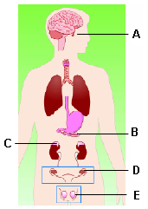

*A pituitary  
B pancreas  
C adrenal glands  
D ovary  
E testis* **(5 marks)**

12. List two differences between antibiotics and vaccines. (**2 Marks**)

*Antibiotics are for bacterial infections (0.5) and cannot be used for vaccines (0.5)*

*TO RECEIVE THE MARK, STUDENT MUST IDENTIFY VACCINE AND ANTIOBOTICS*

*I.E DO NOT ACCEPT “one is for bacterial”*

*Vaccines are a preventative (0.5)*

*Antibiotics are used post-contraction OR kill bacteria OR reactive (0.5) or any reasonable response that describes that it is after contraction of disease*

13. For a hormone of choice, name its origin, its target organ, and the response in the body (**4 marks)**

*Any of the origin organ, target tissue, and effect from the list of hormones below*

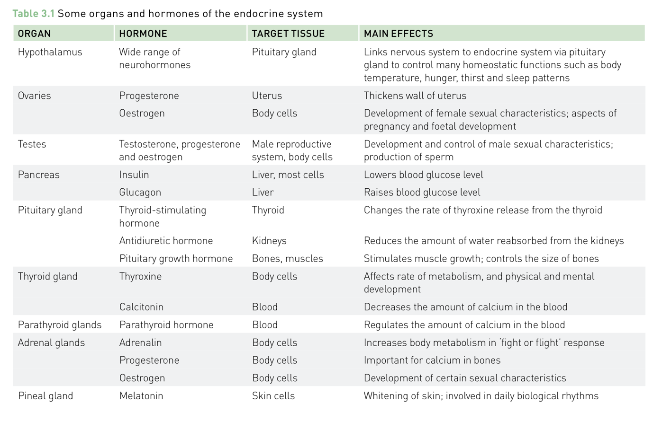

14. Explain the three lines of defence that the body has to prevent infection. (**6 marks**)

|  |  |
| --- | --- |
| Line of Defence | How does it prevent infection? |
| 1st | ***Skin / mucus (1)***  ***Act as a barrier (1)*** |
| 2nd | ***White blood cells / neutrophils (1)***  ***Any of the possible combinations receive (1)***  ***Signal, identify, begin to destroy, inflame the area*** |
| 3rd | ***Lymphatic system / lymphocytes (1)***  ***Any of the possible combinations receive (1)***  ***Destroy, consume, attack*** |

1. Explain how vaccines are created and how they work within the body to prevent infection.

(**4 marks**)

***Creation of vaccine***

* ***Taking a small amount of the poison produced by the bacterium and making it inactive or by using a dead bacteria/weakened pathogen/parts of pathogen (1 mark)***

***Preventing infection***

* ***Body produces antibodies specific to disease ( 1 mark)***
* ***Actual pathogens cause a faster immune response (1)***
* ***because the body “remembers” it, killing disease before infection can occur (1 mark)***

***MAXIMUM 3 MARKS***

13. Read the information below and in the table to answer questions (a) – (d) (5 marks)

Soil was shaken up thoroughly with water and then filtered. The filtrate contained soil bacteria. Carbolic acid (a common disinfectant) was added to six test tubes labelled A-F in different concentrations (amounts). Test tube G only contained distilled water and no bacteria. These test tubes were plugged with sterile cotton wool and kept at the temperatures indicated in the table. If bacteria grew under these conditions, the carbolic acid changed from clear to cloudy.

|  |  |  |  |  |  |  |  |
| --- | --- | --- | --- | --- | --- | --- | --- |
| **Test tube** | A | B | C | D | E | F | G |
| Concentration of carbolic acid | 0.2% | 0.1% | 0.05% | 0.05% | 0.025% | 0.0125% | 0  Distilled water |
| Temperature oC | 10˚C | 25˚C | 25˚C | 10˚C | 25˚C | 25˚C | 25˚C |
| After 7 days | Clear | Cloudy | Cloudy | Clear | Clear | Clear | Clear |
| After 14 days | Cloudy | Cloudy | Cloudy | Cloudy | Cloudy | Clear | Clear |

1. Which tubes show that the disinfectant has not killed the bacteria? (1 mark)

***A B C D AND E***

1. Which is the least concentration of carbolic acid that kills bacteria? (1 mark)

***0.0125% at 250C***

1. What do the results from tubes C and D suggest? (1 mark)

***That carbolic acid works better at lower temperatures/ lower temperatures delay bacteria growth.***

1. What do the results from tube C and E suggest? (1 mark)

***That the lower concentration in E was effective for longer.***

1. Why do you think test tube G was included? (1 mark)

***As a control/comparison.***

**Extended response** (**5 marks**)

Read the scenario below in order to identify the disease

During the school holidays, Mr Opacak went South Africa for a hiking trip for a week. When he arrived home, he began experiencing flu-like symptoms, his joints became swollen and he has developed rashes on his arms and legs. When Mr Opacak went to the doctors for treatment, they said he would recover after a week. Mr Opacak reported he had been bitten by some ‘bugs’. Mr Opacak did not get vaccinated for before he left for his trip.

You are the take the place of Mr Opacak’s doctor and write a report that includes the following information in the space below:

* A possible diagnosis (identification of the disease),
* Whether the disease is bacterial or viral,
* The possible cause for the disease,
* The treatment for the disease, and
* Possible methods of prevention when travelling in the future

*The likely disease: Ross river virus / mosquito borne disease (1)*

*Bacterial/Viral: Viral (1)*

*Possible cause for disease: bitten by a mosquito/bug (0.5) that was carrying the disease (0.5)*

*Treatment for disease: can only treat symptoms of diseases OR there is no cure for viral diseases (1)*

*Possible methods of prevention: any logical prevention strategy*

*Eg: vaccination, bug spray, wear long sleeves (1)*